3.1 | 122-125 | 3,7,9,17,19,23 | Central Tendency
3. Length of school years. The lengths of school years in a sample of various countries in the world are shown. Find the mean, median, midrange and mode of the data.
251 243 226 216 196 180
Mean

Median
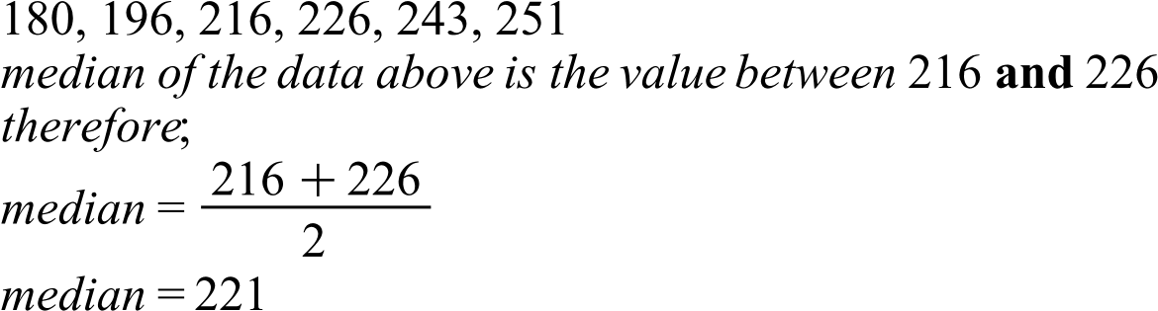
Midrange
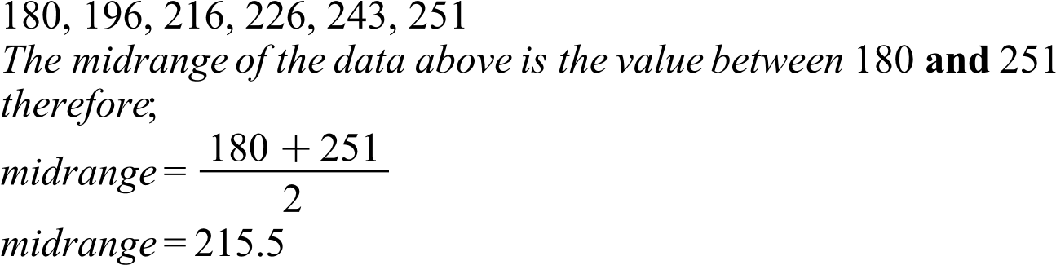
Mode
All the values above occur once and therefore there is no specific mode of the data
7. Paid days off. The data show the number of paid days off workers get in a sample of various countries of the world. Find the mean, midrange and mode for the data.
38 29 10 34 28 30 30 26 19 20 25
Mean

Midrange
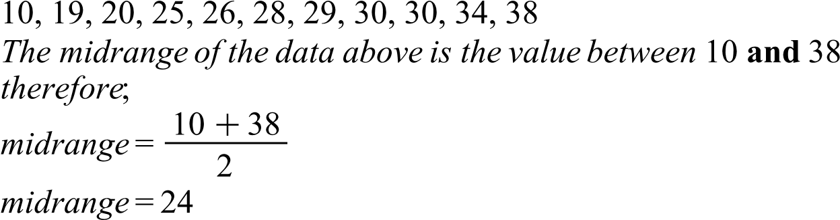
Mode
The mode of the data is 30
9. Airline passengers. The data show a sample of the number of passengers in millions that major airlines carried for a recent year. Find the mean, median, midrange and mode for the data.
143.8 17.7 8.5 120.4 33.0 7.1 27.1 10.0 5.0 6.1 4.3 3.1 12.1
Mean
Median
Midrange
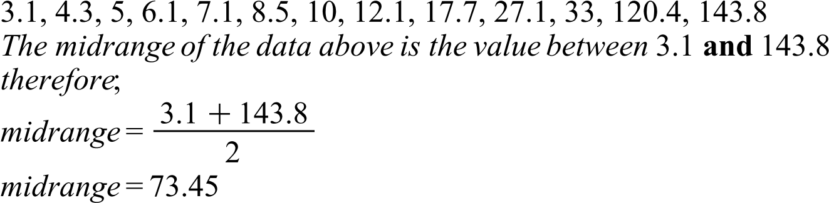
Mode
All the values above occur once and therefore there is no specific mode of the data
17. Percentage of college-educated population over 25. Below are the percentages of the population over 25 years of age who have completed 4 years of college or more for the 50 states and the district of Columbia. Find the mean and modal class.
Percentage | Frequency(F) | Mid-Point(X) | FX | CF
15.2-19.6 | 3 | 17.4 | 52.2 | 3
19.7-24.1 | 15 | 21.9 | 328.5 | 18
24.2-28.6 | 19 | 26.4 | 501.6 | 37
28.7-33.1 | 6 | 30.9 | 185.4 | 43
33.2-37.6 | 7 | 35.4 | 247.8 | 50
37.7-42.1 | 0 | 39.9 | 0 | 50
42.2-46.6 | 1 | 44.4 | 44.4 | 51
 | ∑F= 51 |  | ∑FX=1359.9
 | CF=Cumulative Frequency
Mean

Modal Class
The modal class of the above data is 24.2-28.6
19. Specialty coffee shops. A random sample of 30 states shows the number of specialty coffee shops for a specific company. Find the mean and modal class for the data.
Class Boundaries | Frequency(F) | Mid-Point(X) | FX | CF
0.5-19.5 | 12 | 10 | 120 | 12
19.5-38.5 | 7 | 29 | 203 | 19
38.5-57.5 | 5 | 48 | 240 | 24
57.5-76.5 | 3 | 67 | 201 | 27
76.5-95.5 | 3 | 86 | 258 | 30
 | ∑F= 30 |  | ∑FX=1022
 | CF=Cumulative Frequency
Mean

Modal Class
The modal class of the above data is 0.5-19.5
23. Automobile selling prices. Find the weighted mean price of three models of automobiles sold. The number and price of each model sold are shown in this list.
Model | Number (N) | Price (P) in $ | NP
A | 8 | 10000 | 80000
B | 10 | 12000 | 120000
C | 12 | 8000 | 96000
 | ∑N= 30 |  | ∑NP=296000
Weighted Mean

